**Bergy Wind Turbine Guide**

Contents

I. Bergy Information from suppliers 2

A. Generator parameters 2

B. Rectifier and Filters specifications 2

C. Power information from graph 3

D. Control Info 4

E. Calculations based on information 4

II. MATLAB/Simulink modeling 5

A. Simulink Model Explanation 5

PMSG parameters Calculations 5

Rectifier 6

Inverter 7

Coefficient of Power (CP) calculations 8

Synchronous Frame VOC: PQ Closed-Loop Control 8

APC integration 10

B. MATLAB code explanation 11

III. Troubleshooting Information 12

IV. Appendix 12

A. Table provided by Manufacturer 12

B. Table Frequency vs Windspeed 12

C. Table RPM vs Windspeed with power adjusted for 90% efficiency 13

D. Table voltage vs windspeed with 90% adjustment and current estimation for de DC 13

E. Table voltage vs windspeed with 90% adjustment and resistance estimation for de DC 13

F. Simulink Permanent Magnet Synchronous Machine (PMSM) 13

G. Approach for transfer-function simulation 15

H. Rectifier/DC to AC converter 17

V. References 18

# Bergy Information from suppliers

## Generator parameters

Table : Parameters from the supplier.

|  |  |
| --- | --- |
| **Stator Resistance [Ω]** | 0.51 |
| **Stator Inductance [H]** | 0.0128 |
| **Inertia [kg•m2]** | 174.8 |
| **Static Friction [N•m]** | 5 |
| **Voltage Constant [V/Hz] (peak)** | 9.85 |
| **Operating Current [A]** | 30 |
| **Max RPM [rpm]** | 140 |
| **Rated Wind Speed [m/s]** | 11 |
| **Rated Power [kW]** | 15 |
| **Rated RPM [rpm]** | 135 |
| **Efficiency [%]** | 90 |

## Rectifier and Filters specifications

The table 2 shows the different values of the rectifier and both filters’ values. Figure 1 shows the LTspice model of the Bergy 15 and its model representation using three controlled voltage sources. Diodes named Big are the ones of the rectifier. The controlled current source is used for changing output voltage as it where a resistor.

Table : Rectifier and Filters specifications

|  |  |
| --- | --- |
| **Rectifier Diodes** | |
| **Forward Voltage [V]** | 0.6 |
| **Ron [Ω]** | 0.001 |
| **Snubber capacitance Cs [F]** | 0 |
| **Snubber Resistance Rs [Ω]** | 0.0000001 |
| **Load filter** | |
| **Capacitance [C]** | .022 |
| **Capacitor internal resistance [Ω]** | .00084 |
| **Motor filter/before rectifier** | |
| **Capacitance [C]** | 0.000055 |
| **Capacitor internal resistance [Ω]** | 0. 001 |

Figure : LTspice model of circuit and PMSG representation.

## Power information from graph

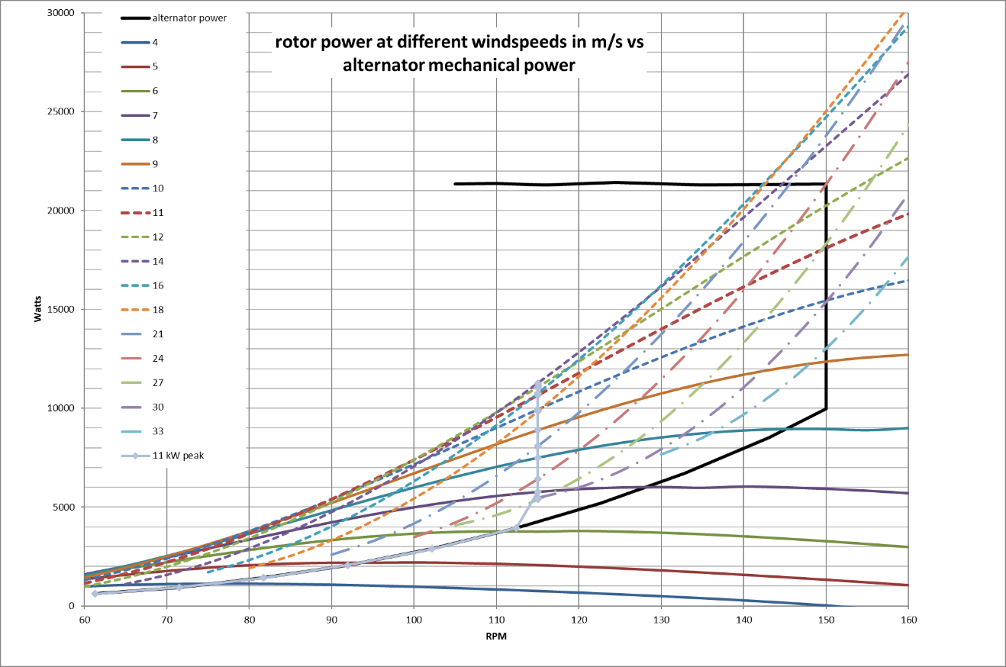

Figure : Power curve of Bergy 15 RPM vs Mechanical Power by wind.

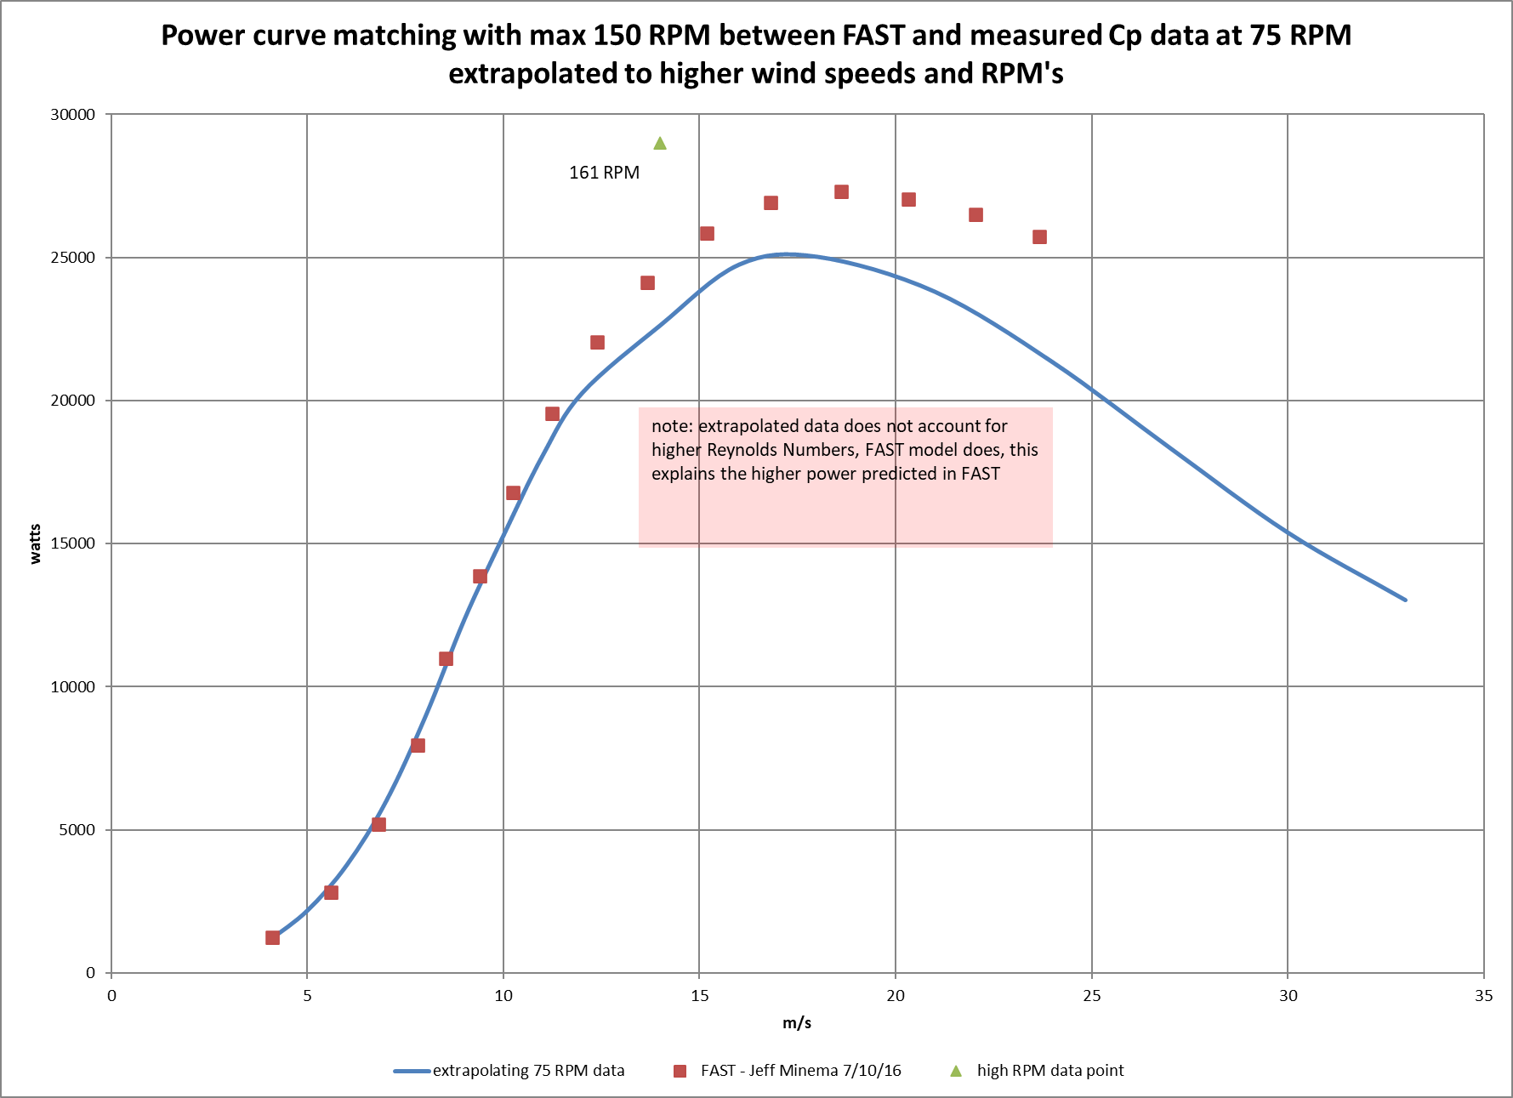

Figure : Power Matching curve Wind speed vs Mechanical Power.

## Control Info

## Calculations based on information

Since 9.85 V/Hz was provided by the manufacturer this number can be used to estimate the expected value from the DC side. There are two ways to achieve:

1. frequency to obtain the voltage

Using equation 1 to obtain the frequency. Then multiply 9.85 V/Hz with the frequencies calculated to obtain the voltages (*see equation 2*). To obtain the voltage and current for the DC side use the passive full-wave 3-phase rectifier (*see equations 3-6 or Appendix H*) with this is possible to obtain values near to the expected.

By substituting (10), (11) in (12) is possible to obtain the following equation:

1. rpm to obtain the voltage

Using equation 1 to determine the frequency at a specific RPM. Then calculate a voltage at that specific frequency using equation 2. Equation 7 was used to obtain the by volving for *x,* 2.751 V/RPM. To obtain the voltage and current for the DC side use the passive full-wave 3-phase rectifier *(see equations 3-6 or appendix H)* with this is possible to obtain values near to the expected for the DC side.

**NOTE:** **These values are not possible to confirm using LTspice model or any MATLAB/Simulink. Discrepancies is about 5% of error to the theorical value from the tables. Insufficient information. See Appendix A-D to see values calculated**

# MATLAB/Simulink modeling

## Simulink Model Explanation

### PMSG parameters Calculations

See Appendix F to know which values are needed to use the Permanent Magnet Synchronous Machine use depending in your rotor type. For this model the following image presents the values used provided by the manufacturer. There is additional information in the *Specify* tab which are the following: torque constant (N•m/A_peak) and flux linkage established by magnets (V•S) (*see figure 4*). These values can be obtained in two ways, by calculations using the MATLAB calculator discussed in the appendix or in [1]. Figure 4 shows the parameters needed for the PMSG of the Simulink model. Figure 5 shows the calculator to help insert the values for the PMSG Simulink model. Figure 6 shows how to measure the resistance. In our case this image is only a reference to know that when asked in the PMSG calculate the phase-phase resistance or inductance it refers to line to line measures. So, one phase values need to be multiplied by two or added up, to input that value in the calculator correctly.

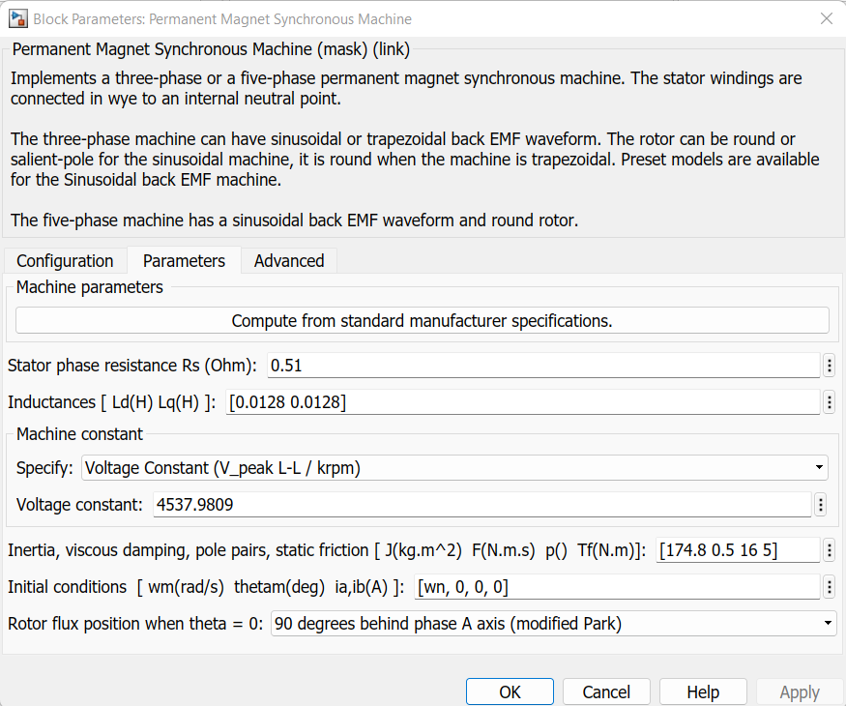

Figure : PMSG parameters from Simulink.

Figure : PMSG Parameter Calculator

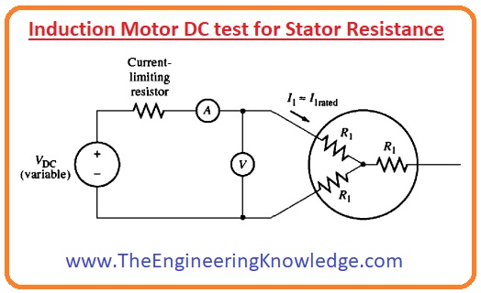

Figure : Showing how resistance and inductance when measured [2]

### Rectifier

For the rectifier it was used the Universal Bridge from Simulink with the values provided by the manufacturer. For discrete simulation in Simulink snubber capacitance needs to be changed to inf to be able to run simulation. For more information of passive rectifier operation refer to Appendix *H*. Figure 7 shows the block used for the rectifier. Figure 8 shows the parameters used.

Figure : Universal Bridge from Simulink

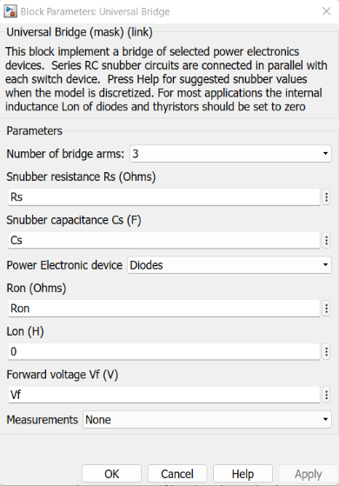

Figure : Universal Bridge Block parameters

### Inverter

For the inverter it was used a Three-Level Bridge from Simulink. See figure 9 to see values.

Figure : Three-Level Bridge parameters from Simulink

### Coefficient of Power (CP) calculations

For this section the approach was to obtain the mechanical power from the data provided by the manufacturer (*see appendix A*). Figure 10 shows the method used for CP calculations. As it can be seen Windspeed is one of the inputs through u2 and RPM is the input through u1. The Look-up table block uses those values to obtain the mechanical power from the data provided by the manufacturer as a xls file called for this model InfoRPMWind.

Figure : Method implemented in the model for CP calculation

### Synchronous Frame VOC: PQ Closed-Loop Control

PQ closed-loop voltage-oriented control based on the synchronous *dq* frame controller operates as follows: the active and reactive powers are calculated using measurements at the B9 and their values are compared with their set-points. The set points in the simulation are Qcmd (reactive) and Pcmd (real) the values come from the APC. Then PI-based controllers decide the reference d and q components of the reference current while the control of the DC voltage acts directly on the reference current *id*.* The closed-loop control allows the dynamics of active/reactive power control to be decided as a consequence of a variation of the grid voltage change. Figure 9 shows the flowchart of the control and each part of the controller [3].

Figure : PQ closed-loop voltage-oriented control based on the synchronous dq frame [3]

Figure : Control in Simulink

### APC integration

The APC has the following inputs:

|  |  |
| --- | --- |
| ft [Hz] | grid frequency (measured in controller) |
| frequency_setpoint [Hz] | 60 |
| Pin [W] | Calculated in PQ controller |
| mode | Desired mode values (an array of 2 values) |
| protection | Set to true. If false deactivates APC |
| Qin | Calculated in PQ controller |
| Voltage | Vabc_B9: Measured by Line B9 |
| Voltage_setpoint | VB9: Nominal voltage |

For the APC some of the values come from the control. The frequency, phase voltage and currents of the lines are obtained from B9 (three-Phase VI measurement block). Pin and Qin are a result of some calculations, also part of the controller to obtain the P and Q of the line. Mode and protection are preselected from the MATLAB code.

Figure : APC used in the model

Figure : Inside the APC block used in the Simulink model

## MATLAB code explanation

The figure 15 presents the MATLAB code divided by its section. Each line of the code is explained in the mat file.

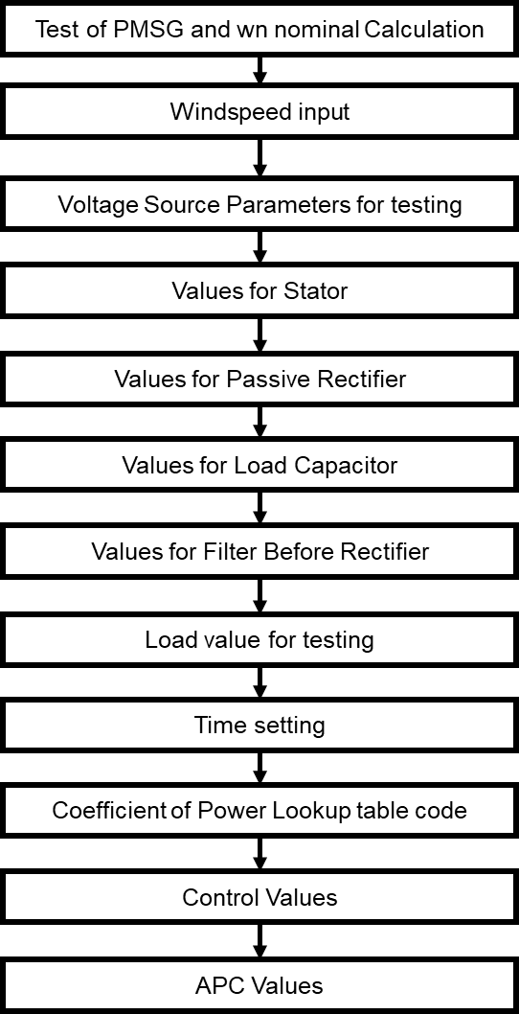

Figure : Code in MATLAB divided by section

# Troubleshooting Information

* Model works in discrete where Ts=2e-5.
* Input Torque should be negative.
* Increasing Vdc or load resistance makes RPM go up. Reducing Voltage or decreasing load resistance RPM goes down. Increasing load resistance is not the same as increasing load, it is inverse.

# Appendix

## Table provided by Manufacturer



## Table Frequency vs Windspeed



## Table RPM vs Windspeed with power adjusted for 90% efficiency



## Table voltage vs windspeed with 90% adjustment and current estimation for de DC

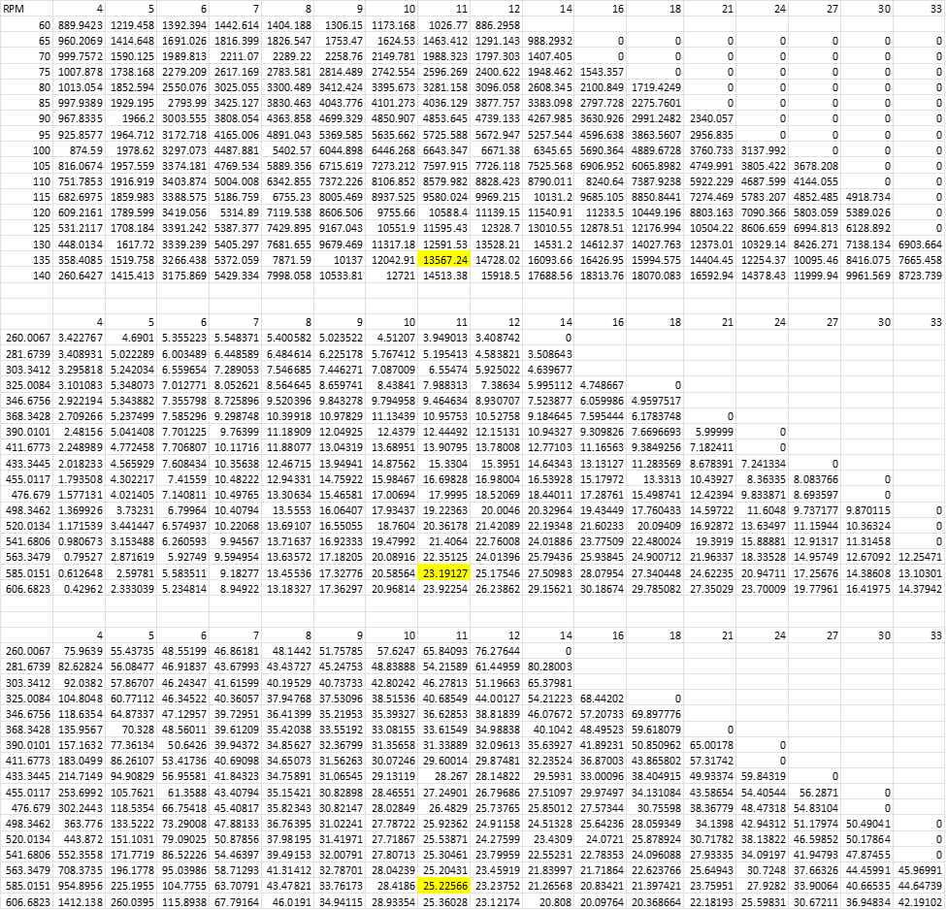

## Table voltage vs windspeed with 90% adjustment and resistance estimation for de DC

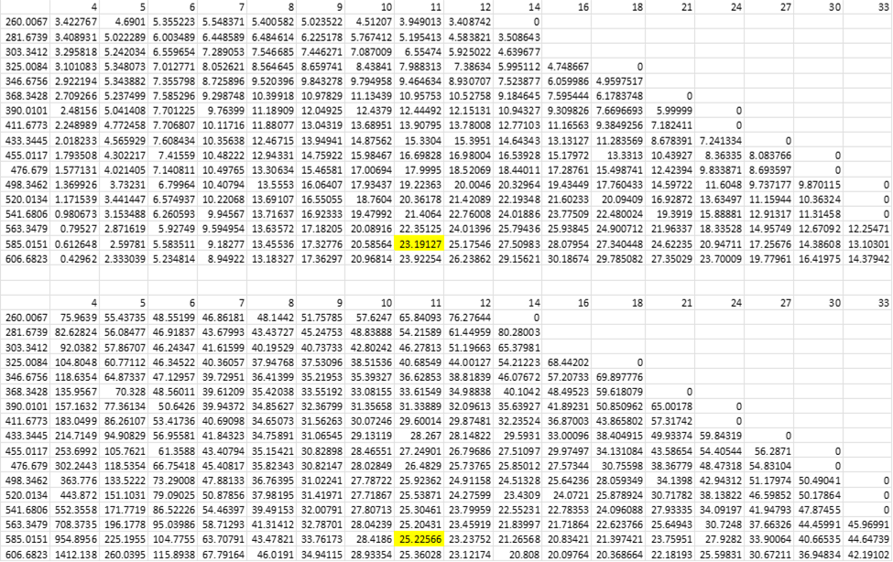

## Simulink Permanent Magnet Synchronous Machine (PMSM)

The following outline has the different specifications needed for the PMSM. Section I.A are the specifications needed for the parameter calculator. Section I.B shows Block Parameters that are needed directly without the need of the parameter calculator. With this information it is possible to obtain all the values needed.

* 1. Back EMF waveform:
     1. Sinusoidal
        1. Rotor type-Round:
           1. Resistance (ph-ph) [R]
           2. Inductance (ph-ph) [Lab]
           3. Specify (at least one of the following)

Torque constant [kt]

Units: (oz•in,lb•in,lb•ft,N•m,N•cm)/(Apeak,Arms)

Voltage constant [ke]

Units: (Vrms,Vpeak)/(krpm,rad/s)

* + - * 1. Inertia [J]

Units: (lb•in•s2, kg•m2, kg•cm2,g•cm2, lb•in2, oz•in•s2, g•cm2)

* + - * 1. Viscous damping [F]

Units: (oz•in/krpm,N•m•s,N•m/rpm, oz•in/krpm)

* + - * 1. Pole pairs [p]
      1. Rotor type-Salient Pole:
         1. Resistance (ph-ph) [R]
         2. D-axis inductance (ph) [Ld]
         3. Q-axis inductance (ph) [Lq]
         4. Specify (at least one of the following)

Torque constant [kt]

Units: (oz•in,lb•in,lb•ft,N•m,N•cm) /(Apeak,Arms)

Voltage constant [ke]

Units: (Vrms,Vpeak)/(krpm,rad/s)

* + - * 1. Inertia [J]

Units: (lb•in•s2, kg•m2, kg•cm2,g•cm2, lb•in2, oz•in•s2, g•cm2)

* + - * 1. Viscous damping [F]

Units: (oz•in/krpm,N•m•s,N•m/rpm, oz•in/krpm)

* + - * 1. Pole pairs [p]
    1. Trapezoidal
       1. Round Specifications needed
       2. Resistance (ph-ph) [R]
       3. Inductance (ph-ph) [Lab]
       4. Specify (at least one of the following)
          1. Torque constant [kt]

Units: (oz•in,lb•in,lb•ft,N•m,N•cm)/(Apeak,Arms)

* + - * 1. Voltage constant [ke]

Units: (Vrms,Vpeak)/(krpm,rad/s)

* + - 1. Inertia [J]

Units: (lb•in•s2, kg•m2, kg•cm2,g•cm2, lb•in2, oz•in•s2, g•cm2)

* + - 1. Viscous damping [F]

Units: (oz•in/krpm,N•m•s,N•m/rpm, oz•in/krpm)

* + - 1. Pole pairs [p]
  1. Block Parameters
     1. Sinusoidal
        1. Rotor type-Round:
           1. Stator phase resistance Rs [ohm]
           2. Armature Inductance [H]
           3. Flux linkage established by magnets [V•s]
           4. Voltage Constant [Vpeak L-L/krpm]
           5. Torque Constant [N•m/Apeak]
           6. Inertia, fiction factor, pole pairs [kg•m2, N•m•s, poles no units]
        2. Rotor type-Salient Pole:
           1. Stator phase resistance Rs [ohm]
           2. Inductances Ld [H], Lq [H]
           3. Flux linkage established by magnets [V•s]
           4. Voltage Constant [Vpeak L-L/krpm]
           5. Torque Constant [N•m/Apeak]
           6. Inertia, fiction factor, pole pairs [kg•m2, N•m•s, poles no units]
     2. Trapezoidal
        + 1. Stator phase resistance Rs [ohm]
          2. Stator phase inductance Ls [H]
          3. Flux linkage established by magnets [V•s]
          4. Voltage Constant [Vpeak L-L/krpm]
          5. Torque Constant [N•m/Apeak]
          6. Inertia, fiction factor, pole pairs [kg•m2, N•m•s, poles no units]

## Approach for transfer-function simulation

Section II presents the different steps to obtain the transfer function beginning from the *Wind Energy Conversion* ending with the rectifier/DC to Ac converter.

1. Wind Energy Conversion [1,2,3,4]
   1. Notations/Terms:

* – wind power
* – air density
* – wind velocity
* – area the covered surface of the turbine
* – radius of turbine which the wind passes
* – power coefficient
* – tip ratio speed
* – blade pitch angle
* – mechanical power
* – rotor torque
* – rotor speed
* – total inertia
* – electric torque
* – viscous friction
  1. Equations:

By substituting (1) in (2) it can be obtained (mechanical power):

By substituting (5) in (6) it can be obtained (turbine torque):

The wind power generator dynamic equation:

1. PMSG Model
   1. Notations/Terms

* – number of pole pairs
* – magnetic flux
* – q-axis current flowing through stator
* – d-axis current flowing through stator
* – resistance of stator
* – inductance
* –input voltage of the stator’s q-axis
* –input voltage of the stator’s d-axis
  1. Equations:

For this part I skipped the process of substitution (*see references for more information*) to get the following [1,2,3,4]:

## Rectifier/DC to AC converter

For the Bergy 15 WT the manufacturers use a passive full-wave rectifier this may vary between manufacturers. Figure 1 shows a 3phase circuit with a rectifier. Figure 2 shows the voltage of the 3 phases as an input to the rectifier, at the bottom presents the output voltage waveform from the rectifier.

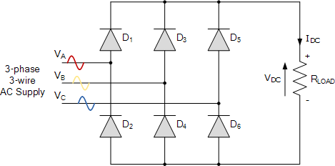

*Figure 16: Full-wave circuit for a 3-phase system.*

*Figure 17: Voltage wave of a 3-phase system and output of a passive full-wave 3-phase rectifier.*

The following equations are not of the dynamic system of a passive full-wave 3-phase rectifier:

By substituting (10), (11) in (12) is possible to obtain the following equation:

# References

[1]Matlab, "Parameterize a Permanent Magnet Synchronous Motor". [Online]. Available: https://www.mathworks.com/help/physmod/sps/ug/parameterize-a-permanent-magnet-synchronous-motor.html.

[2]"Induction Motor DC test for Stator Resistance and Locked Rotor Test - The Engineering Knowledge", The Engineering Knowledge. [Online]. Available: https://www.theengineeringknowledge.com/induction-motor-dc-test-for-stator-resistance-and-locked-rotor-test/.

[3]R. TEODORESCU, *Grid converters for photovoltaic and wind power systems*. [Place of publication not identified]: WILEY-BLACKWELL, 2011.

[4]S. Lee and K. Chun, "Adaptive Sliding Mode Control for PMSG Wind Turbine Systems", *Energies*, vol. 12, no. 4, p. 595, 2019. Available: 10.3390/en12040595.

[5]V. Vijayan, "Design and Control of Permanent Magnet Synchronous Generator for Variable Speed Wind Energy Conversion System Using Sliding Mode Control", *International Journal of Science and Research (IJSR)*, vol. 5, no. 6, pp. 132-138, 2016. Available: 10.21275/v5i6.nov164084.

[6]F. Naama, A. Zegaoui, Y. Benyssaad, F. Kessaissia, A. Djahbar and M. Aillerie, "Model and Simulation of a Wind Turbine and its Associated Permanent Magnet Synchronous Generator", *Energy Procedia*, vol. 157, pp. 737-745, 2019. Available: 10.1016/j.egypro.2018.11.239.

[7]P. Sen, Principles of electric machines and power electronics.